Clinton Hawkes

Joseph Stallano

**Project Step 2 - ER Diagram & Schema**

7/14/19

1. **Fixes**

We were instructed to change all of our string variables to variables of type varchar, so we made these changes in the Database project outline, The changes are reflected in the new outline below.

We removed the author from the book entity. With a many-to-many relationship, it no longer makes sense from a design perspective to have the author entity inside the book table.

**B. Outline - Updated Version**

**Database Project**

Joseph Stallano

Clinton Hawkes

Project Outline

We will be creating a database to be used by a fictional local library in Oregon. Libraries must store detailed information about the many different types of informational mediums they possess. Having a spreadsheet or other data store to keep track of all these different sources of information is not very effective, and it would slow down the research process considerably. Using a relational database allows its users to group information together so employees and patrons of the library can efficiently search for related information. This is why we chose this theme for our database. Our database will only store information pertaining to books, but it will provide a glimpse of the utility a relational database provides its users.

Database Outline

**The entities in the database are:**

Book:

PK=ISBN

* ISBN (integer) - unique book identifier obtained and assigned by the publisher. Only one copy of each book is available.
* Title (varchar) - title of the book. Has a maximum length of 100 characters and cannot be blank. There is no default.
* Publisher (varchar) - maximum length is 50 characters. Cannot be blank. No default value.
* Location (varchar) - this will contain the id of the Facility at which the book is located and must be one of the following 3 options. (Main, Burbank or Riverton). Default is Main.

Author:

PK=Author ID

* Author ID (number) - auto generated primary key, cannot be null, and no default
* First Name (varchar) - maximum length is 25 characters. No default. Required.
* Last Name (varchar) - maximum length is 25 characters. No default. Required.
* Home city (varchar) - maximum length is 25 characters. No default.
* Home state (varchar) - maximum length is 25 characters. No default.

Publisher:

PK=Publisher ID

* Publisher ID (integer) - auto generated primary key, cannot be null, and no default
* Company Name (varchar) - Publisher’s name. Maximum length is 50 characters. Required. No default.
* Owner (varchar) - Maximum length is 50 characters.
* City (varchar) - maximum length is 25 characters.
* State (varchar) - maximum length is 2 characters. State is identified by its abbreviation. Required.

Facility:

PK=Facility ID

* Facility ID (integer) - auto generated primary key, cannot be null, and no default
* Branch (varchar) - name of the library branch. Maximum length is 25 characters. Required. No default.
* Street Address (varchar) - maximum length is 100 characters. Required. No default.
* City (varchar) - maximum length is 25 characters. Required. No default.
* State (varchar) - maximum length is 2 characters. Required. Default is “OR”.
* Capacity (# books) (integer) - maximum value is 10,000,000. No default.

Loan:

PK=Loan ID

* Loan ID - auto generated primary key, cannot be null, and no default
* ISBN (number) - contains id of book being loaned. Required. No default.
* Customer (number) - contains id of customer receiving book. Required. No default.
* Loan Date (date) - date the book was loaned to the customer. Required. Default is the date the record is created.
* Due Date (date) - date the book is due back to the library. Required. Default is two weeks from the loan date.

Customer:

PK=Customer ID

* Customer ID (number) - auto generated primary key, cannot be null, and no default
* First Name (varchar) - maximum length is 25 characters. No default. Required.
* Last Name (varchar) - maximum length is 25 characters. No default. Required.
* Street Address (varchar) - maximum length is 50 characters. No default. Required
* City (varchar) - maximum length is 25 characters. Required. No default.
* State (varchar) - maximum length is 2 characters. Required. Default is “OR”.
* Zip (varchar) - maximum length is 5 digits. Required. No default.

**The relationships in the database are:**

* A book can have many authors, and an author can write many books. (Many-to-many)
* A facility can have many books, but a book can have only one facility. (One-to-many)
* A book is produced by one publisher, but a publisher produces many different books. (One-to-many)
* A loan must be to one customer, but a customer may have many loans. (One-to-many)
* A loan is for one book, but a book can be loaned many times. (One-to-many)

**Website URL**

Website is running using “forever” on flip3:

<http://flip3.engr.oregonstate.edu:6102/>

**C. Entity-Relationship Diagram**

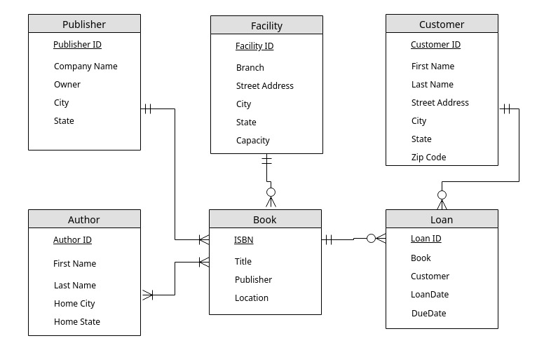

**D. Schema**

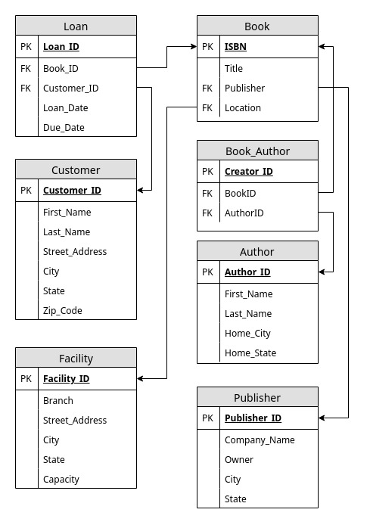

[**Yanhao Huang**](https://piazza.com/class/jx53xtds6531gu?cid=30#)

**ERD**

**1. The attributes in the ERD are the same as that described in the outline**

**2. The participation of entities are the same as that described in the outline**

**3. The cardinality of entities are the same as that described in the outline**

**4. There are no relationships that are better described as an Entity**

**5. The ER Diagram and the database looks good**

**Schema**

**1. The relationship tables are consistent with the database outline**

**2. The foreign keys are consistent with the database outline**

**3. Theres 2 First_name attributes in the Author table, all other entity attributes match the outline**

**4. The Schema and the database looks good**

[**Miao Pan**](https://piazza.com/class/jx53xtds6531gu?cid=30#)

1. **Are the attributes for each entity in the ERD same as that described in the database outline? Yes**
2. **Is the participation of entities in the relationships same as that described in the outline? It's mentioned in the description that "A loan must be to one customer, but a customer may have many loans. (One-to-many)". In the ERD, the diagram indicates a customer can have 0 or more loans. I think it's correct that it's a one-to-many relationship, but it would be clearer if in the description it's stated that the participation could be 0.**
3. **Is the cardinality of entities in the relationships same as that described in the outline? yes.**
4. **Based on the Database outline, could any of the relationships be better off described as an Entity instead ? No.**
5. **Is there something that could be changed/improved in the E R Diagram and/or the overall database design? It looks pretty good.**
6. **Are the relationship tables present where required and correctly defined, when compared with the database outline? yes.**
7. **Are foreign keys present where required and correctly defined, when compared with the database outline? yes foreign keys are present**
8. **Do the entity attributes match those described in the outline? yes**
9. **Is there something that could be changed/improved in the Schema and/or the overall database design? No it looks good.**

[**James Wise**](https://piazza.com/class/jx53xtds6531gu?cid=30#)

**1. Are the attributes for each entity in the ERD same as that described in the database outline?**

**Yes. All of the attributes are present**

**2. Is the participation of entities in the relationships same as that described in the outline?**

**Yes, all of the relationships are described.**

**3. Is the cardinality of entities in the relationships same as that described in the outline?**

**Yes.**

**4. Based on the Database outline, could any of the relationships be better off described as an Entity instead ?**

**No. A library application such as this doesn’t really have complex relationships that could be entities instead**

**5. Is there something that could be changed/improved in the E R Diagram and/or the overall database design?**

**I am curious how you will be showing how a customer is going to be related to a facility to determine where and when a book needs to be returned. If the load is based on the isbn, and 2 or more facilities have the same book (ISBN), the system will not know where the book needs to be returned to by the customer, or if they return to the wrong location, how can the system tell.**

**Another point I was thinking of, what if a author has a publisher change, or has different publishers for different types of books? I know that authors do have different publishers for different regions of the world that the book is released in.**

**1. Are the relationship tables present where required and correctly defined, when compared with the database outline?**

**Yes 2. Are foreign keys present where required and correctly defined, when compared with the database outline?**

**Yes, all keys are present**

**3. Do the entity attributes match those described in the outline?**

**Yes.**

**4. Is there something that could be changed/improved in the Schema and/or the overall database design?**

**The schema looks good**

[**Lifang Yan**](https://piazza.com/class/jx53xtds6531gu?cid=30#)

**ERD**

1. **Are the attributes for each entity in the ERD same as that described in the database outline? Yes**
2. **Is the participation of entities in the relationships same as that described in the outline? Yes**
3. **Is the cardinality of entities in the relationships same as that described in the outline? Yes**
4. **Based on the Database outline, could any of the relationships be better off described as an Entity instead ? No**
5. **Is there something that could be changed/improved in the E R Diagram and/or the overall database design? No**

**Schema**

1. **Are the relationship tables present where required and correctly defined, when compared with the database outline? Yes**
2. **Are foreign keys present where required and correctly defined, when compared with the database outline? Yes**
3. **Do the entity attributes match those described in the outline? Two first name included in AuthorTable.**
4. **Is there something that could be changed/improved in the Schema and/or the overall database design? No**

**Actions Based on Feedback**

We made some changes to the project - Step 2 based on feedback from the discussion. Firstly, we had accidentally created two “First Name” fields in the Author table, so we removed the additional instance of “First Name”. Secondly, we removed the relationship between author and publisher, as this is a redundant relationship. The book and publisher have a one to many relationship, so this is sufficient, as a book is tied to a publisher or publishers, but an author is not necessarily tied to one publisher or publishers.

**Upgrades to Draft Version**

-Removed second “first name” attribute from author table

-Removed relationship between author and publisher